Changing Your Password and Setting Up MFA

  - Download the Microsoft Authenticator app. This can be found by searching "auth" in the App store for iPhone or Play store for Android. Below is the current icon. Stop here and go to your computer.
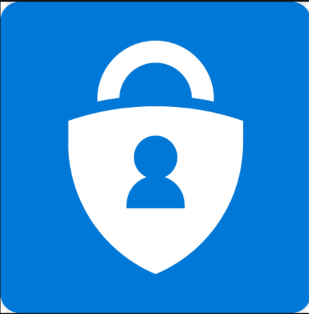
  - On your computer, open a web browser (Chrome, Firefox, or Microsoft Edge) and go to portal.office.com. Below is a picture of the site you will find. Type in your email address. Click next.
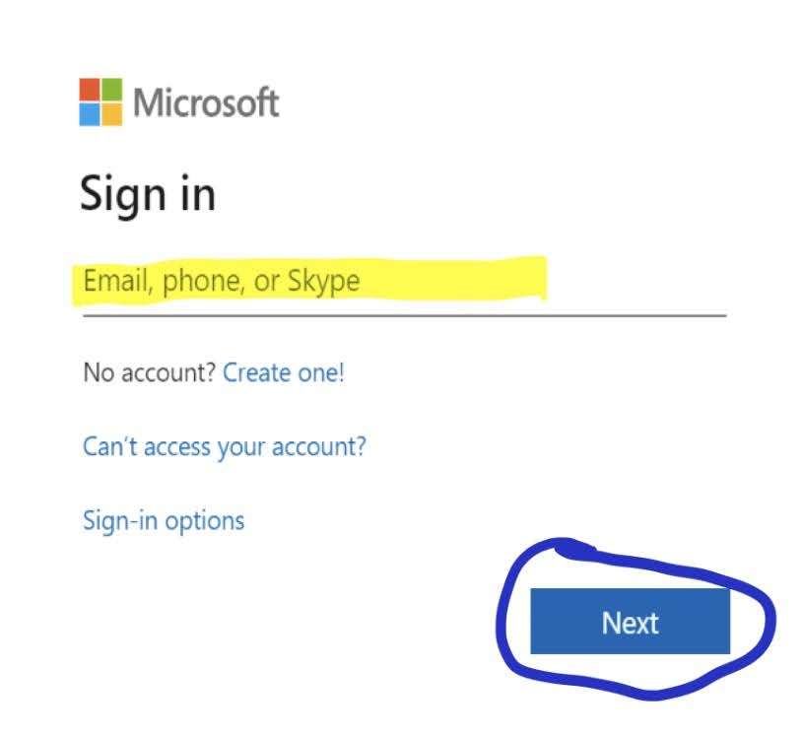
  - On the next screen, type in your temporary password. Click Sign in. ACPE members with Microsoft SharePoint access should have received an email with their temporary password around 8:00am eastern on July 23, 2020. If you did not receive an email with your temporary password, please call the ACPE office at (404) 320-1472 for a staff member to assist you.
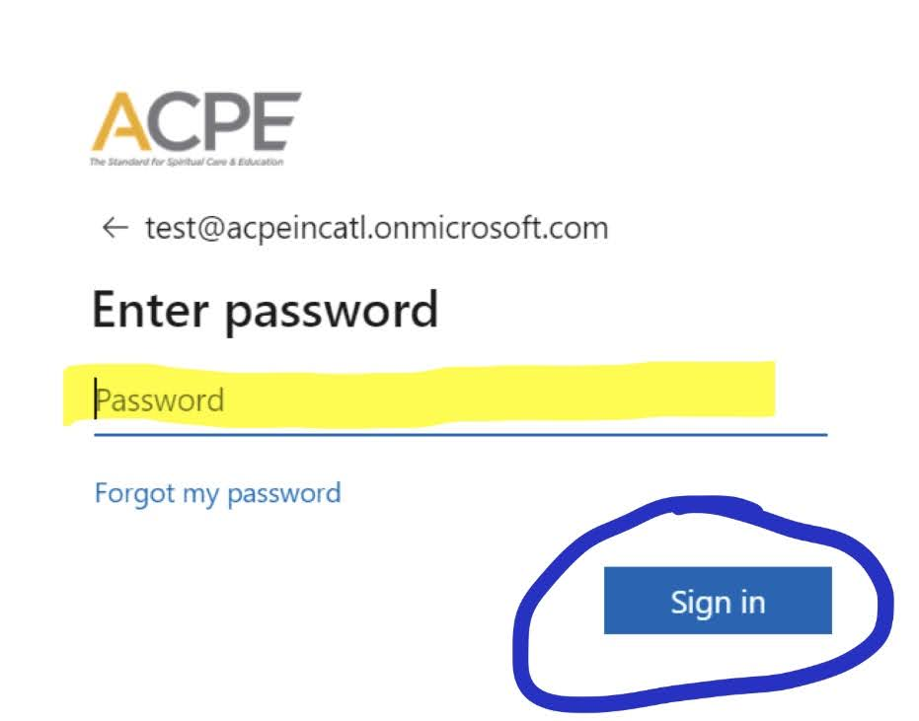
        - On the next screen, click Next.
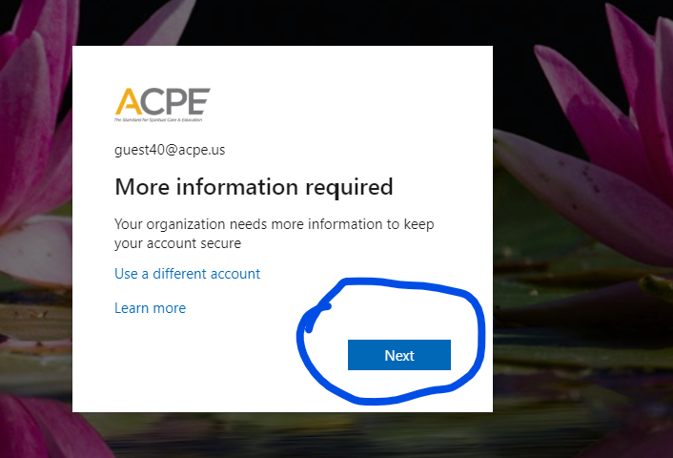
  - On the next screen you will set the options for multi-factor authentication. We will be using the Mobile App set to send notifications. Click the drop-down menu and select Mobile App. Select option to “Receive notifications for verification”. Click Set up.
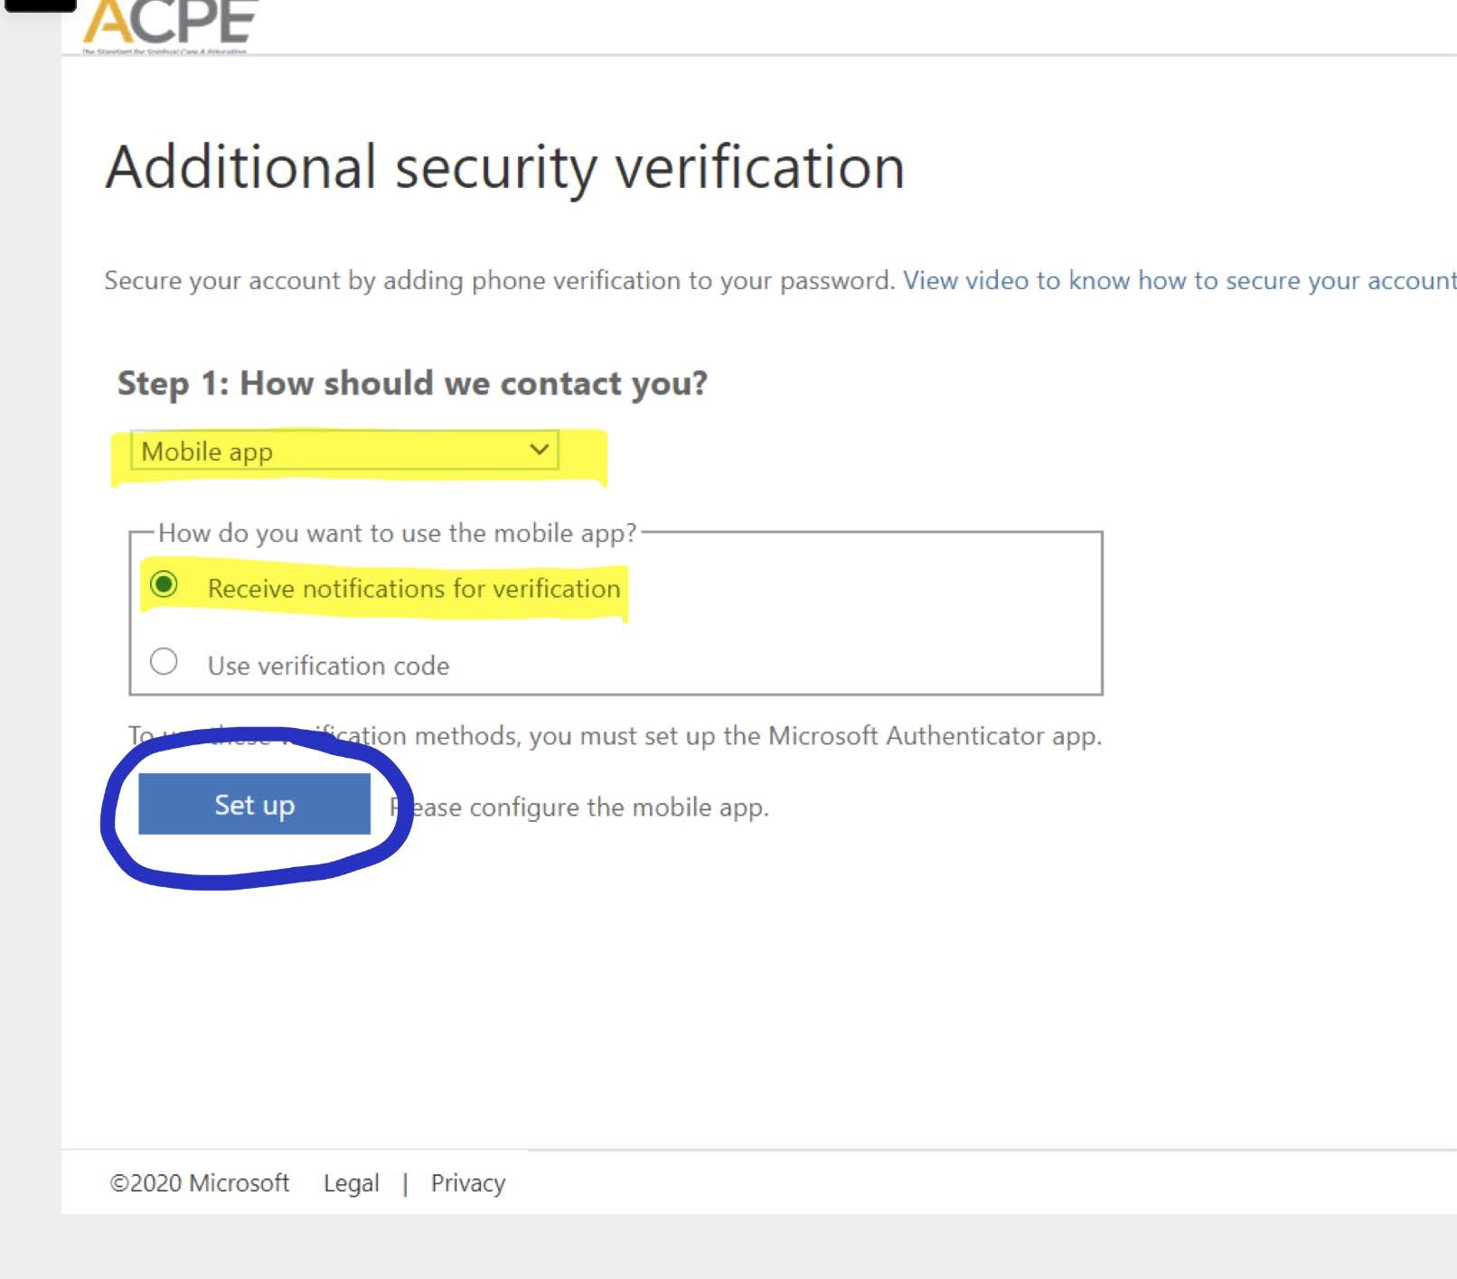
  - The next screen is a QR code. With your mobile phone, open the Authenticator app. The option for Scan QR code is at the bottom. Give the app permission to you use your camera, send notifications, and then scan the code with your phone's camera. Click Next.
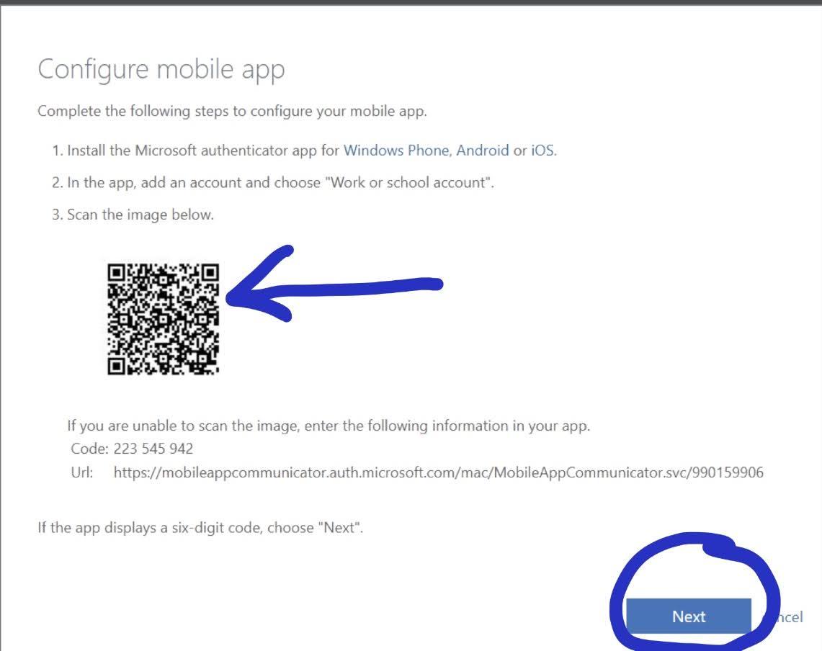
Your app configures itself, and it completed when you see your email. Select it for your one-time pass code. Below is an example.
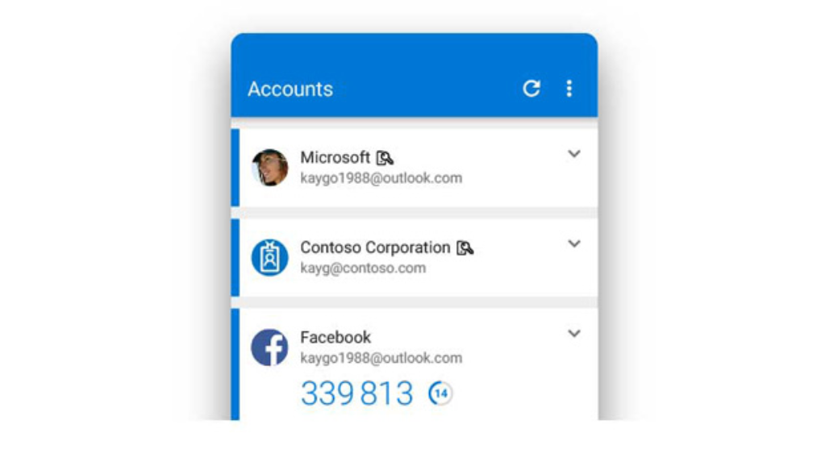
  - On your computer, you will return to the previous page from Step 6. Do not make changes. Click Next.
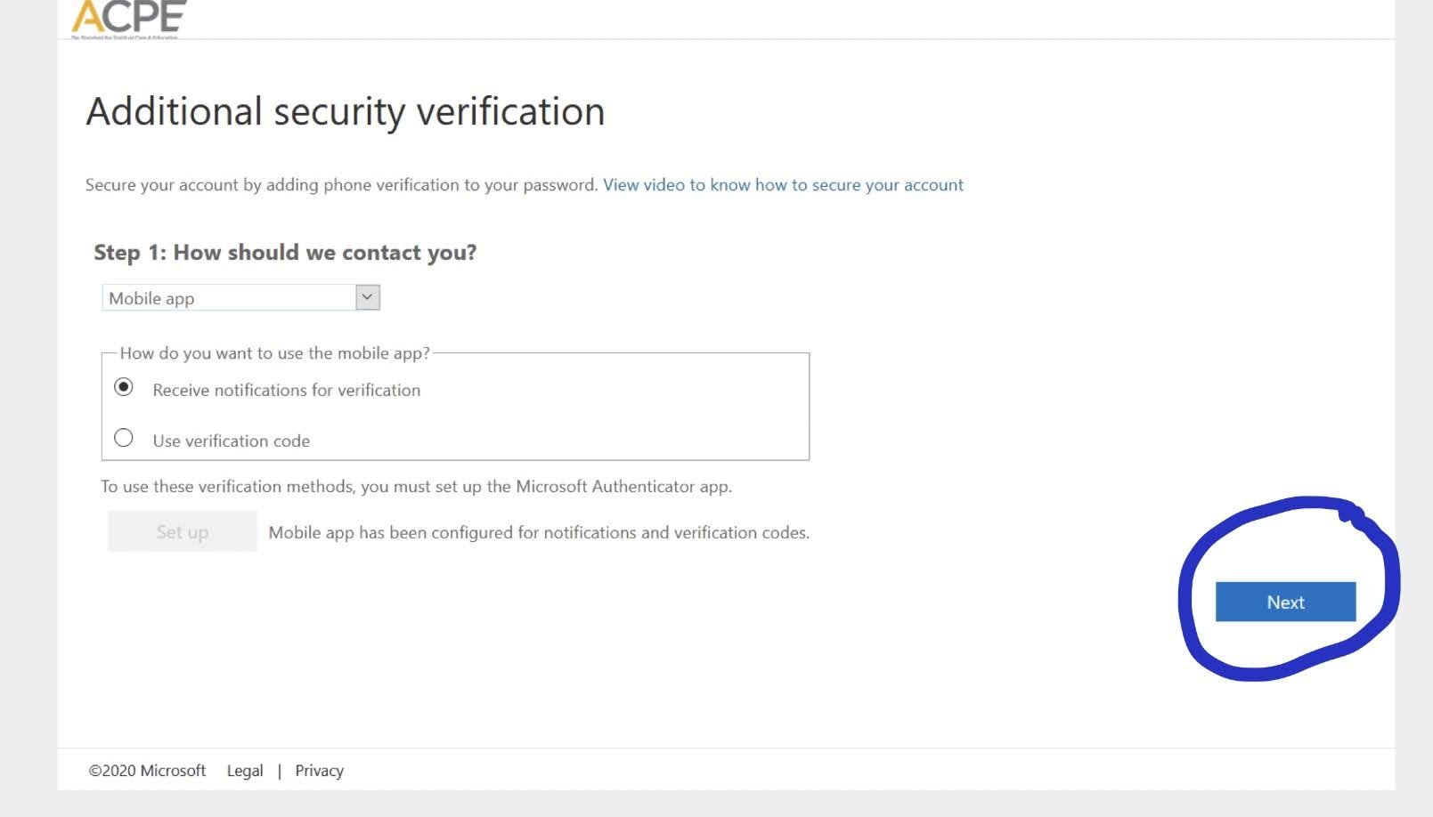
  - The App will test sending notifications. Check your phone for a notification to approve logging in. Below are pictures after clicking next on your computer, and a picture of the notification on your phone.
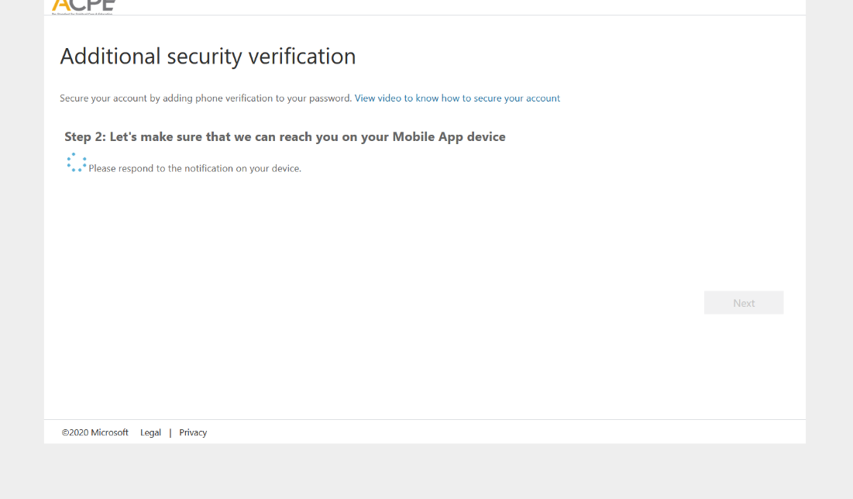
  - On your phone select approve
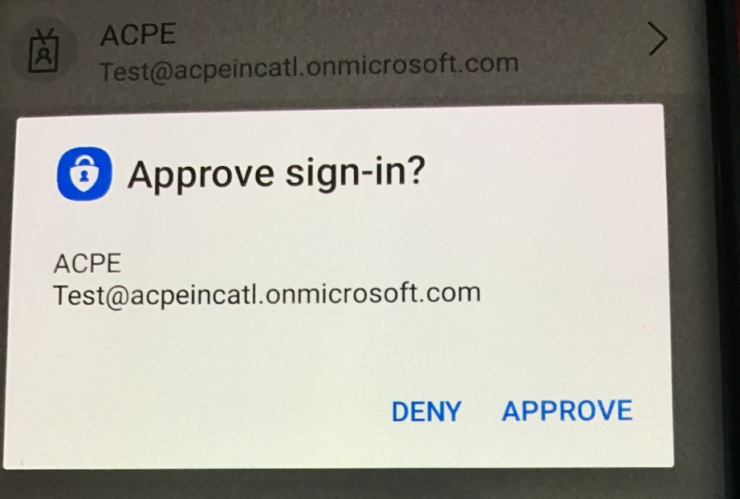
  - Next enter your cell phone. This in case you need to use an alternate method to access email. Click Next.
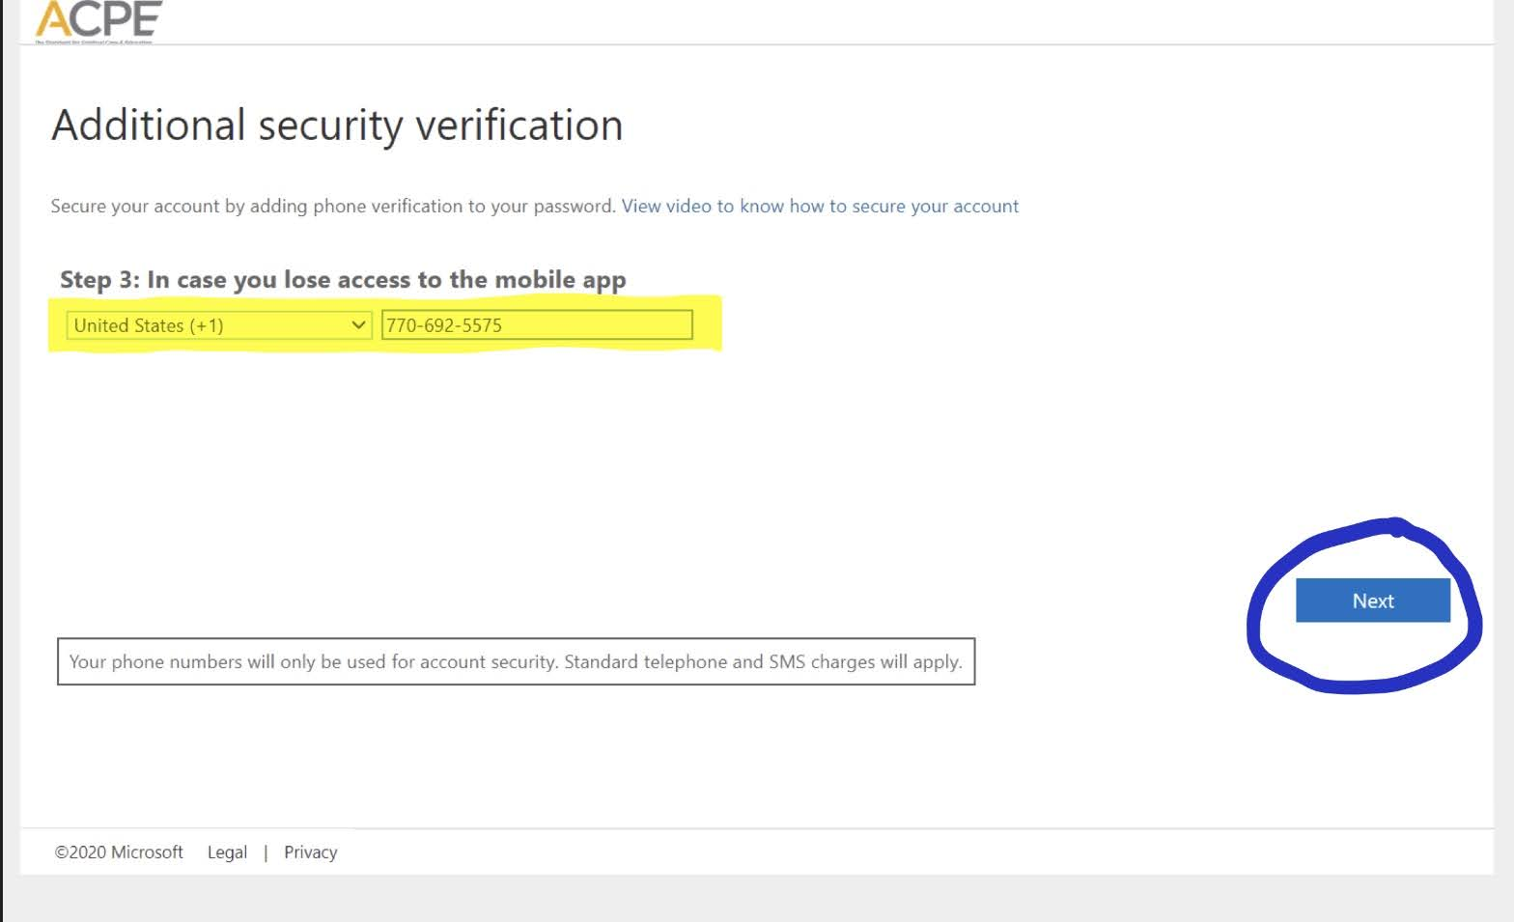

- Microsoft auto generates an app password that is used for devices that do not use modern day authentication. You will not need this, and it does not need to be saved. The admin can generate another key if it becomes necessary in the future. Click Done.
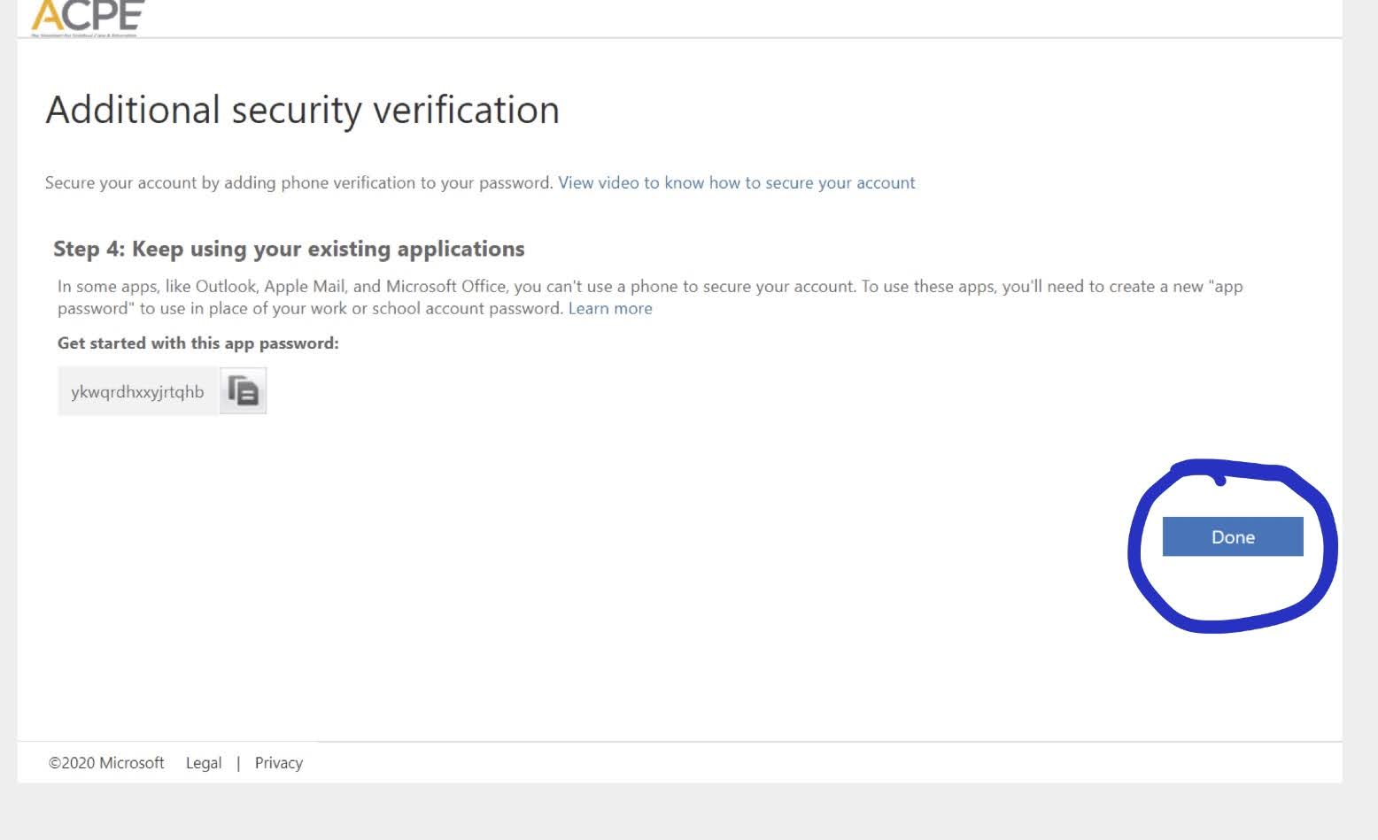
  - You will be required to change your password upon logging in. Type in your temporary password, and then the password you wish to be your new password for Office 365.Click Sign in.
  - Please note: a minimum of 8 characters and include at least one lower case letter, uppercase letter, number and special character (%, $, ^, etc)
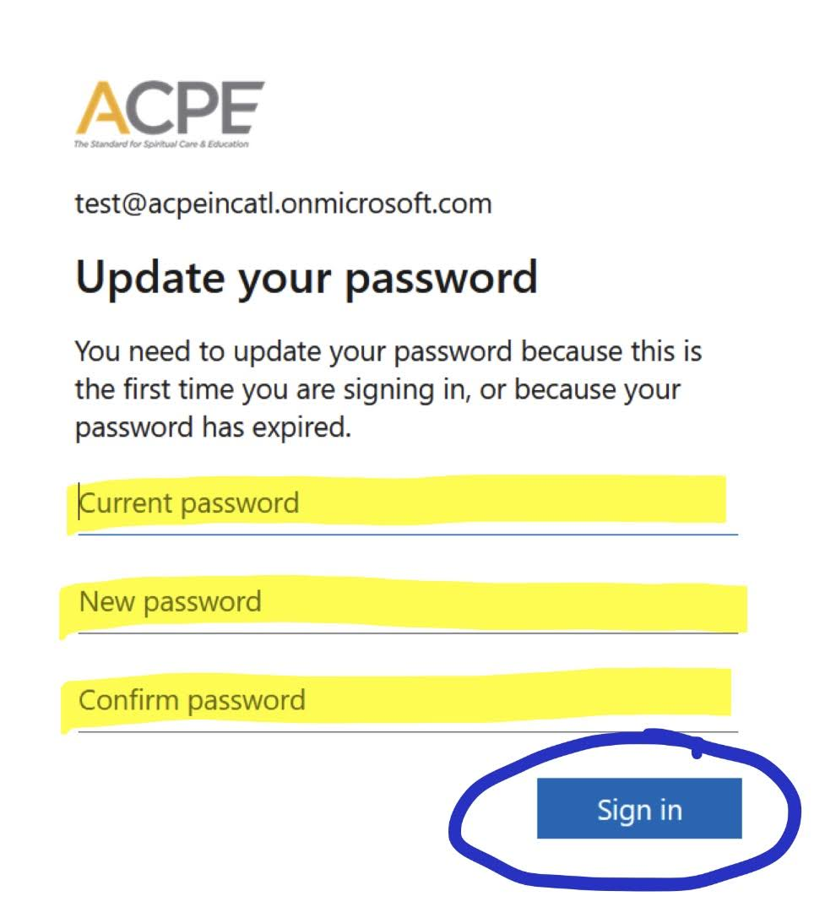
- Below is an example screen of when you are logged. Depending on licensing, your Outlook and other Office apps that are available online will display here.
    - Please Note: Microsoft may request additional information for the purpose of resetting your password if it is ever lost. If you are prompted with this screen you can share the additional information at your discretion. Once completed, or if you wish to skip, click done.
